

**Sri Lanka Institute of Information Technology**

**Data Warehouse and Business Intelligence**

**IT3021**

3rdYear, 1stSemester

Assignment 2

**Weekday Batch**

**Y3S1.15(DS)**

IT19021430

Hillary J.R.

# Acknowledgement

I would like to express my special thanks of gratitude to all the lecturers in charge of the module Data Warehouse and Business Intelligence, as well as Sri Lanka Institute of Information Technology who gave me the golden opportunity to do this wonderful project on the module Data Warehouse and Business intelligence, which also helped me in doing a lot of Research and i came to know about so many new things I am really thankful to them.

Secondly, I would also like to thank my parents and friends who helped me a lot in finalizing this project within the limited time frame.

# Contents

Acknowledgement 2

Contents 3

Introduction 4

1.0 Data source for the assignment 2 5

1.1 Meal Demand Data Warehouse ER Diagram 5

1.2 Data Set Selection 6

1.3 Meal Demand Datawarehouse Data Description 7

1.4 High-Level BI Solution Architecture 10

2.0 SSAS Cube implementation 11

3.0 Demonstration of OLAP operations 20

3.1 Drill Down & Roll Up 20

4.2 Roll Up 22

3.3 Slice 23

3.4 Dice 24

3.5 Pivot 25

3.6 Power View Visualization 26

4.0 SSRS Reports 28

Report 1: Report with a matrix 29

Report 2: Report with more than one parameter. 30

Report 3: Create an SSRS drill-down report. 34

Report 4: Create an SSRS drill-through report. 34

# Introduction

This document contains details related to the Assignment 2 based on the implementation of the Cubes with related to the previously implemented data warehouse on the module Data Warehouse and Business Intelligence. The document also visualizes OLAP operations of the cubes. Each OLAP operations are explained with screen shots from the data retrieved from the Cube implemented. The document also includes SSRS reports and description on each operation with screen shots of the implementation.

# Data source for the assignment 2

## 1.1 Meal Demand Data Warehouse ER Diagram

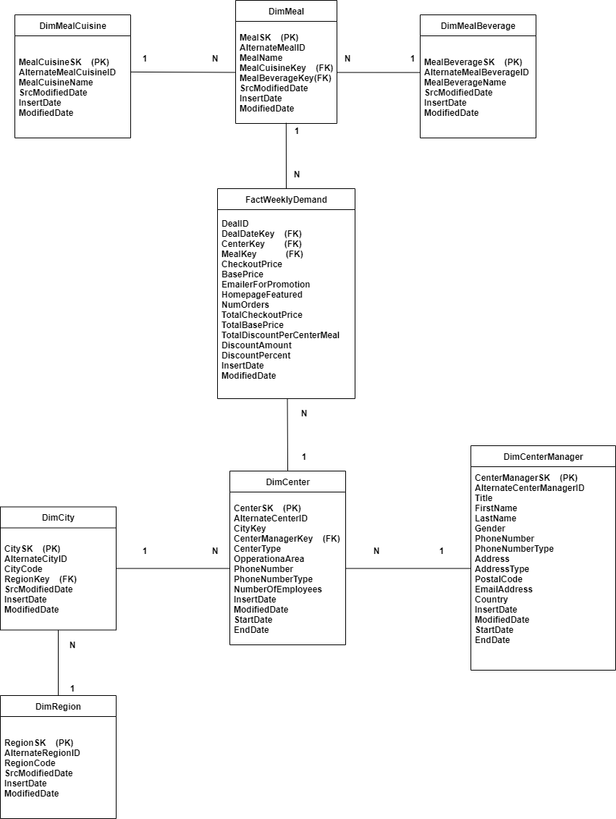

## 1.2 Data Set Selection

The selected data source is a collection of transactional data. The link to the source data set is mentioned below:

Link to chosen data set

<https://www.kaggle.com/ghoshsaptarshi/av-genpact-hack-dec2018>

The select data set is based on a meal delivery company which operates in multiple cities. The data set consists of various fulfillment centers in these cities for dispatching meal orders to their customers. Through the data set can be used to help these centers with demand forecasting for upcoming weeks so that these centers will plan the stock of raw materials accordingly.

Aim of the data set

The source data set is been provided to predict the demand for the next 10 weeks based on the history of 145 weeks for the center meal combinations.

Staffing of centers based on demand

Procurement planning – Raw materials (raw materials are perishable)

The source data set consists

* Historical data of demand for a product-center combination (Weeks: 1 to 145)
* Product (Meal) features such as category, sub-category, current price and discount
* Information for fulfillment center like center area, city information etc.

More details about the Data warehouse implemented are given in the below chart.

## 1.3 Meal Demand Datawarehouse Data Description

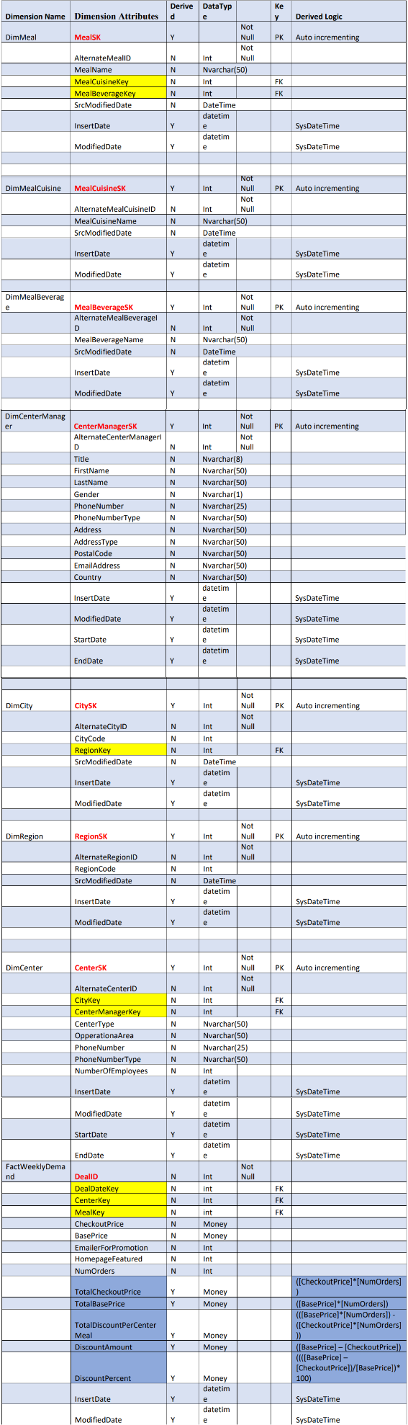

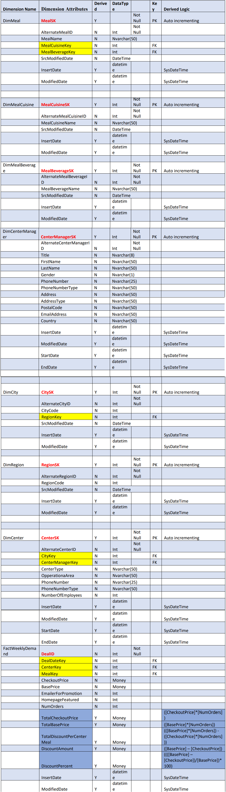



## 1.4 High-Level BI Solution Architecture

The basic concept of a Data Warehouse is to facilitate a single version of truth for a company for decision making and forecasting. A Data warehouse is an information system that contains historical and commutative data from single or multiple sources. Data Warehouse Concepts simplify the reporting and analysis process of organizations.

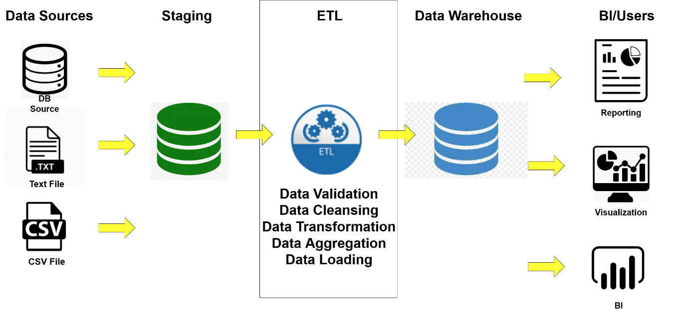

**BI Layer**

In business intelligence, data warehouses serve as [the backbone of data storage](https://chartio.com/learn/data-warehouses/the-data-storage-hierarchy-lakes-warehouses-and-marts/). Business intelligence relies on complex queries and comparing multiple sets of data to inform everything from everyday decisions to organization-wide shifts in focus.

This layer includes

BI Applications - web applications, mobile applications, self-service BI tools, other data mining and modelling tools.

# 2.0 SSAS Cube implementation

**Tools Required**

* SQL Server Data Tools
* SQL Server Management Studio

**Creating a new SSAS Project**

* Create a ‘Business Intelligence’
* Under ‘Analysis Services’ create a project ‘Analysis Services Multidimensional and Data Mining Project.’
* Project Name Given – ‘MealDemand_SSAS’

**Configuring Data Sources.**

* Connected to the Data warehouse previously done – ‘MealDemand_DW’
* Provided the windows specific user name and password when configuring the data source
* Data Source Name – ‘DS_MealDemand_DW’



**Configuring Data Source Views**

* Created the connection to the relational data source previously created ‘DS_MealDemand_DW’
* Create logical relationships by matching columns SK (Primary Keys) and the Alternative Key (Foreign Keys), created the mapping between tables.
* Source View Name – ‘DSV_MealDemand_DW’



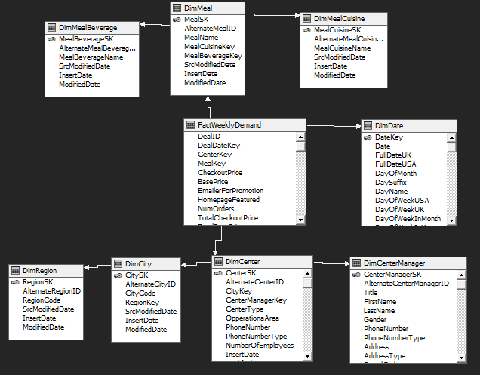

**Cube Creation**

* The data source view had created with the relevant tables in the previous section. We can use this existing data source to create the Cube.
* From the “Cube wizard” select all the measures from the “FactWeeklyDemand” fact table which is needed to include in the cube.
* Select the dimensions “DimMeal”, “ DimMealCuisine”, “ DimMealBeverage”, “DimCenter”, “DimCenterManager”, “DimCity”, “DimRegion”, “DimDate” from the “Cube wizard”.
* Name of Cube – ‘Cube_Meal_Demand.cube’



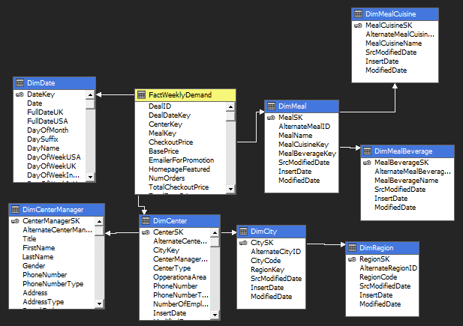

**Configuring Dimensions**

* Implementing necessary hierarchies in each dimension
* Inserting the necessary attributes needed in the cube in each dimension

DimDate - Implementing Hierarchies

1. Year 🡪 Month 🡪 Date
2. Year 🡪 Month 🡪 Week Of Month 🡪 Date
3. Year 🡪 Month Of Quarter 🡪 Month Name 🡪 Week Of Month 🡪 Date

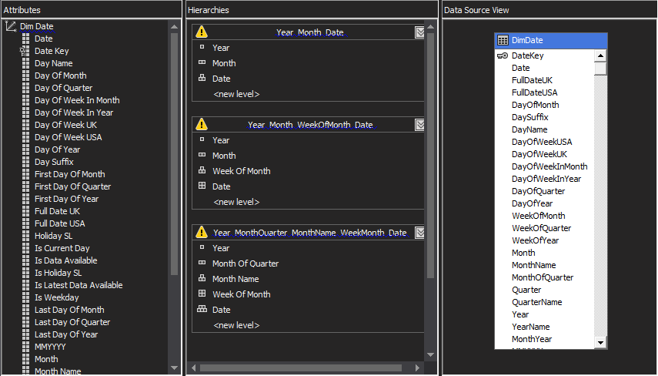

DimCenter – Implementing Hierarchies

1. Center Type 🡪 Region Code 🡪 City Code

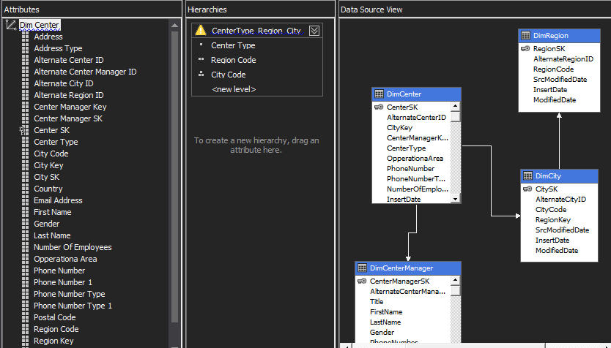

DimMeal – Implementing Hierarchies

1. Meal Cuisine Name 🡪 Meal Beverage Name 🡪 Meal Name
2. Meal Beverage Name 🡪 Meal Cuisine Name 🡪 Meal Name

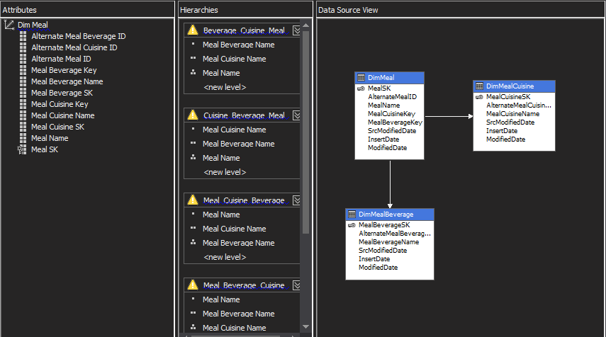

**Deploying the Cube after the Configuration of Cube**

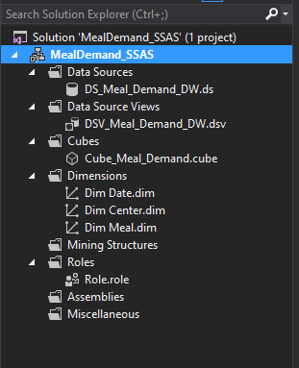

Cube Deployed in SQL Server Management Studio

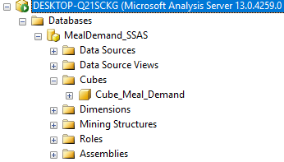

**Creating KPI**

1. KPI NumOrders

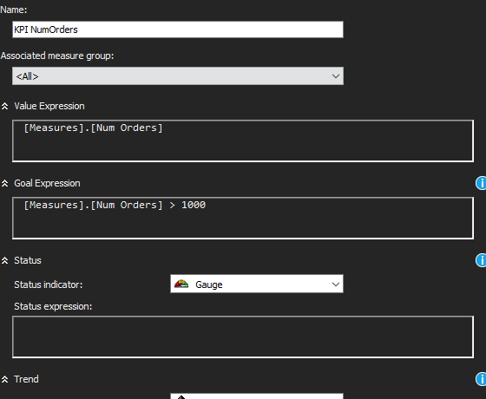

Create KPI to measure

Create KPI to measure the Number of orders If the KPI gets more than 1000 then it means that Meal has sold above the target. So, based on that Client can decide that in that particular KPI value there is more.

1. KPI Discount Amount

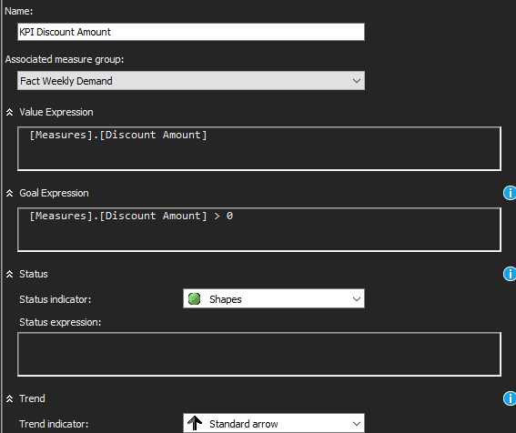

If the KPI Discount Amount > 0 that means there has been a discount offered to the customer in that particular purchase, else there has not been a discount offered.

**Creating a Role**

* Create a Role with full control

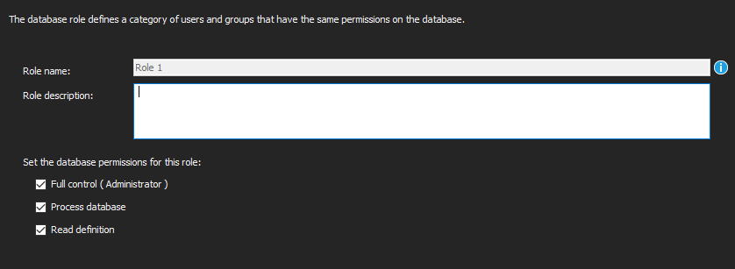

Specify “USER” as the user

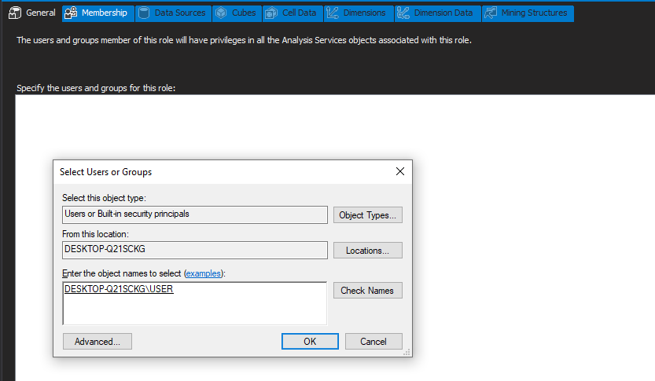

**Deployed Data Cube**

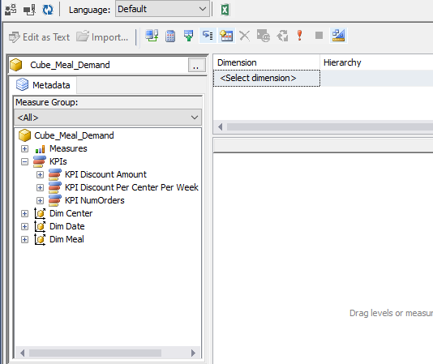

# 3.0 Demonstration of OLAP operations

## 3.1 Drill Down & Roll Up

In drill-down operation, the less detailed data is converted into highly detailed data

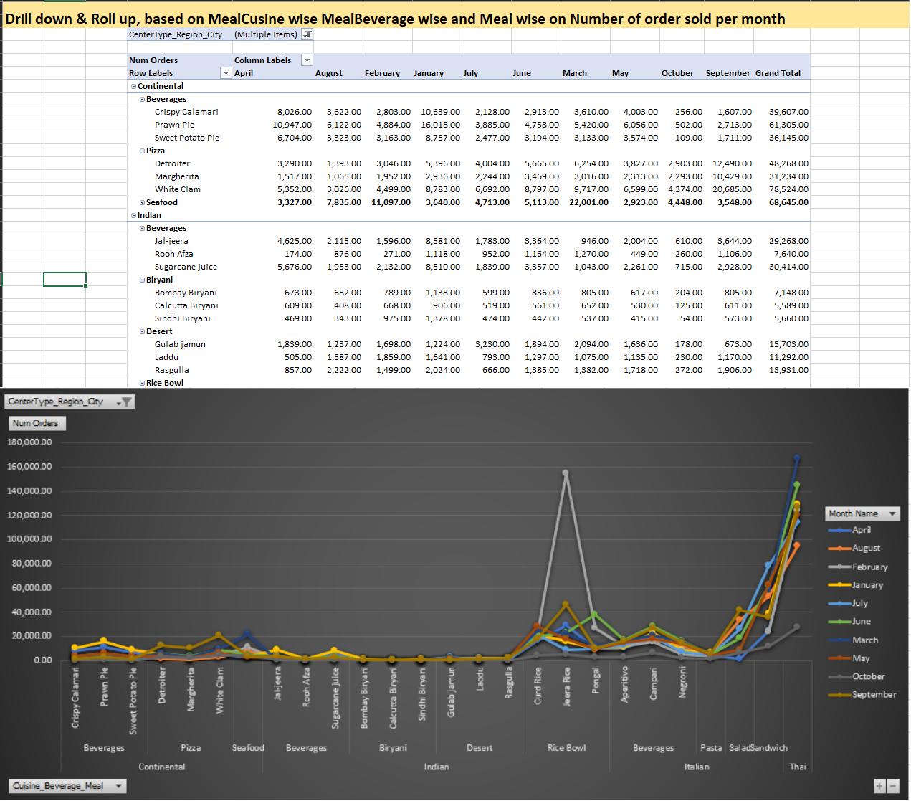

Drill down can be done by:

Moving down in the concept hierarchy

Adding a new dimension

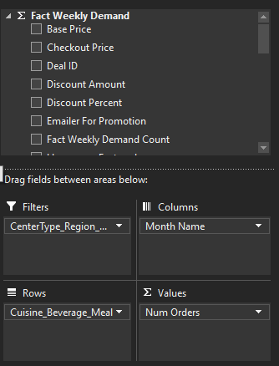

DimMeal, DimDate, DimCenter and Fact for Num Orders are the main dimensions used here.

Here Line chart has been chosen to show the variations of number or orders Cuisine wise, Beverage wise and Meal wise over Month as the time.

Filters has been added to the hierarchy CenterType_Region_City (CenterType 🡪 Region 🡪 City)

In the rows

In the Rows of the table Cuisine_Beverage_Meal hierarchy has been used (Meal Cuisine Name 🡪 Meal Beverage Name 🡪 Meal Name)

For the Values Number of orders has been taken.

So, through this table it is possible to find the number of orders sold per Cuisine_Beverage_Meal based on a particular CenterType_Region_City. The graph shows the variation over the months.

## 4.2 Roll Up

It is just opposite of the drill-down operation. It performs aggregation on the OLAP cube. It can be done by:

Climbing up in the concept hierarchy

Reducing the dimensions

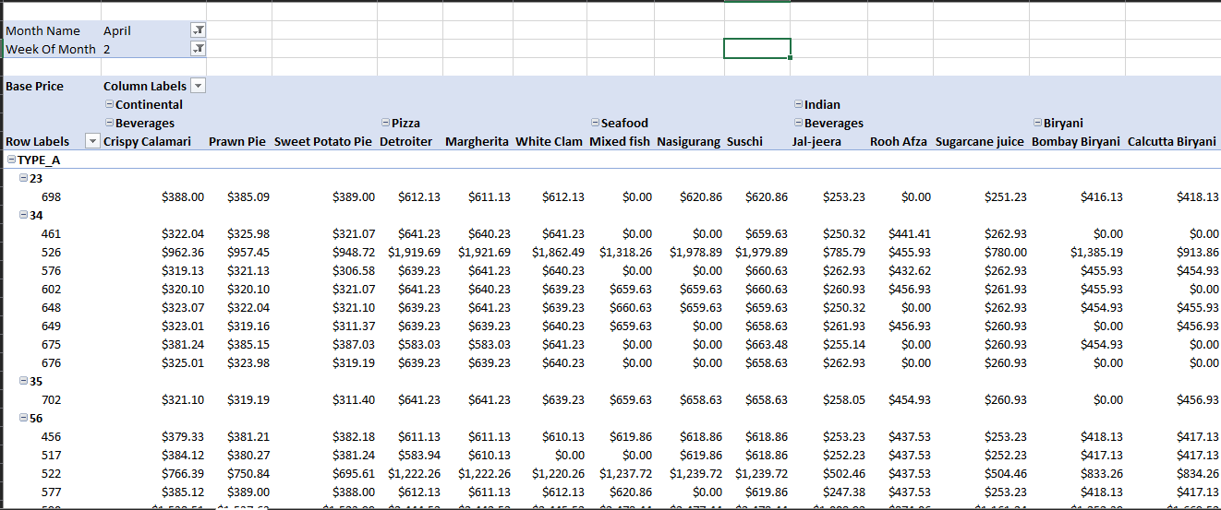

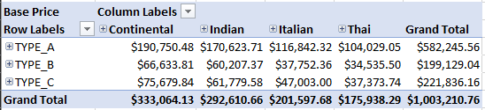

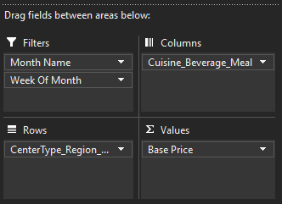

DimDate, DimMeal and DimCenter are the dimensions mainly considered here

Here in the Row wise Center Type 🡪 Region 🡪 City hierarchy has been used.

In the column Meal Cuisine 🡪 Meal Beverage 🡪 Meal hiereachy has beed used

These shows hierarchies shows the drill down and drill thorugh operations on the above chart

To filter the table folders has been added Month wise and Week of Month wise.

## 3.3 Slice

This selects a single dimension from the OLAP cube which results in a new sub-cube creation.

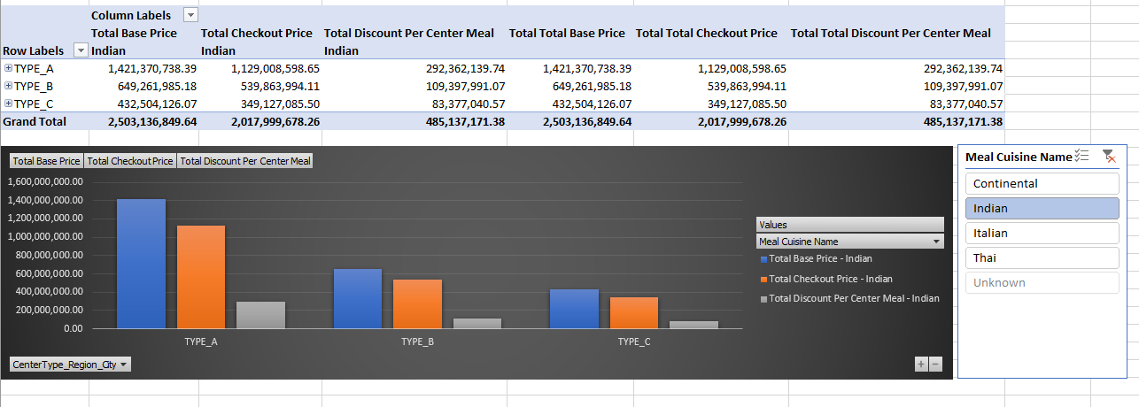

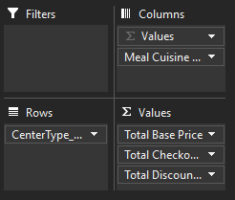

Dim Meal, Dim Center and the Measure from the Fact are used here

Values that are been considered on this chart are Total Base Price, Total Checkout Price, Total Discount Per Center Per Meal.

In the Columns Meal Cuisine is been considered

Where the slices act as a filter over a particular Meal Cuisine.

## 3.4 Dice

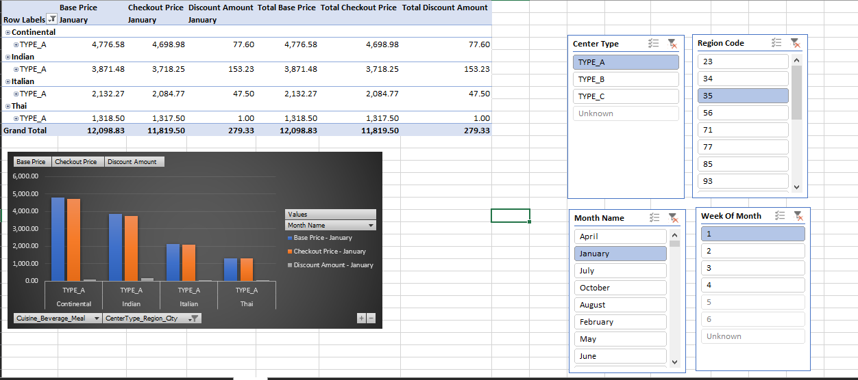

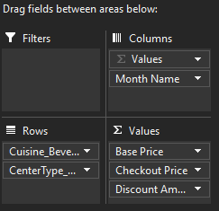

It selects a sub-cube from the OLAP cube by selecting two or more dimensions.

Here DimCenter, DimDate has been mainly considered.

These dimensions and its attributes are used to create the Dice.

## 3.5 Pivot

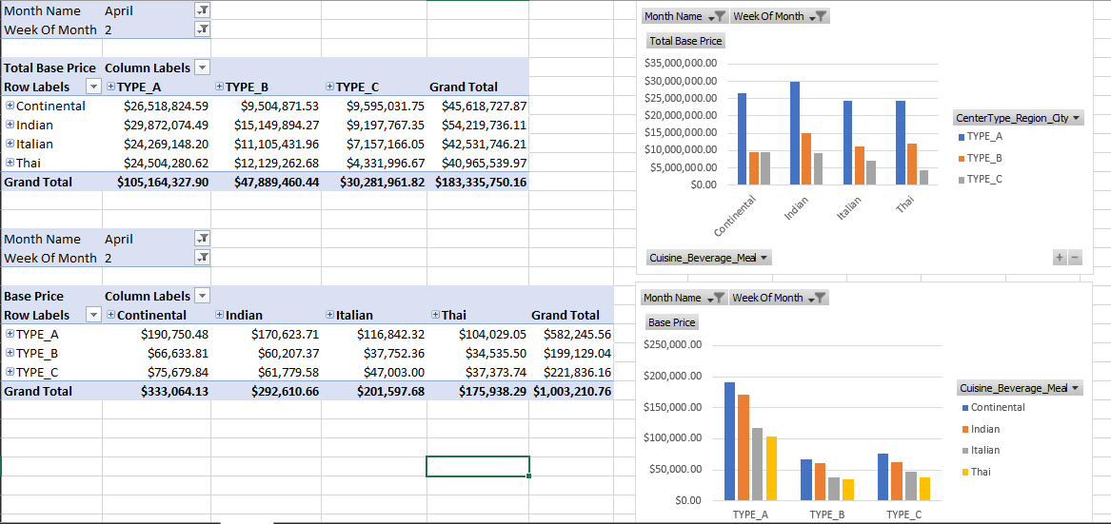

It is also known as rotation operation as it rotates the current view to get a new view of the representation.

Mainly DimMeal, DimCenter are considered dimensions here.

## 3.6 Power View Visualization

MDX Query

|  |
| --- |
| SELECT NON EMPTY  { KPIValue("KPI NumOrders"), KPIGoal("KPI NumOrders") }  ON COLUMNS, NON EMPTY  { ([Dim Meal].[Beverage_Cuisine_Meal].[Meal Name].ALLMEMBERS * [Dim Center].[CenterType_Region_City].[City Code].ALLMEMBERS )  }  DIMENSION PROPERTIES MEMBER_CAPTION, MEMBER_UNIQUE_NAME ON ROWS FROM [Cube_Meal_Demand] CELL PROPERTIES VALUE, BACK_COLOR, FORE_COLOR, FORMATTED_VALUE, FORMAT_STRING, FONT_NAME, FONT_SIZE, FONT_FLAGS |

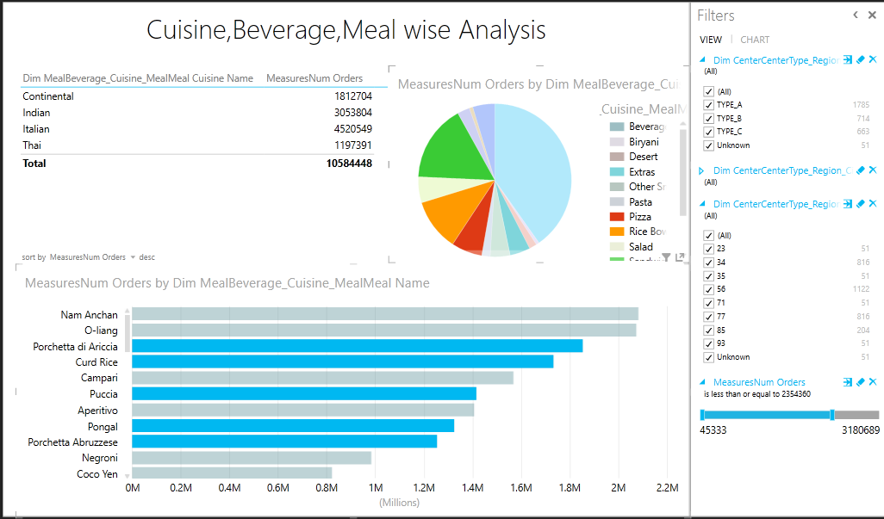

This visualization is based on Meal Cuisine wise, Meal Beverage wise, Meal analysis based on the number of orders sold from the whole data set.

Filtering has been applied for Center Type, Region and City, also for the number of orders.

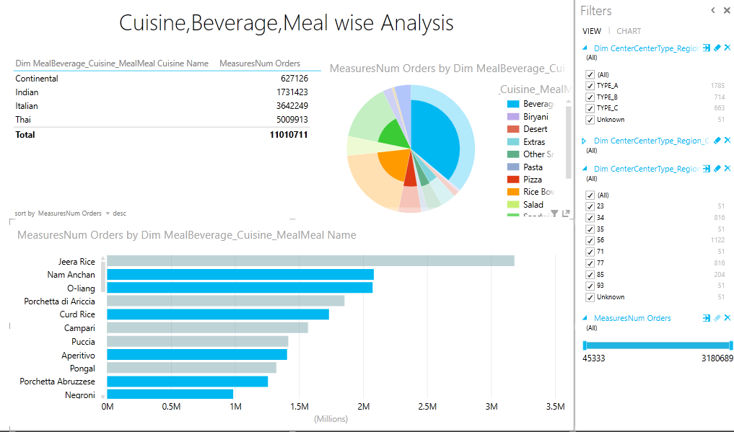

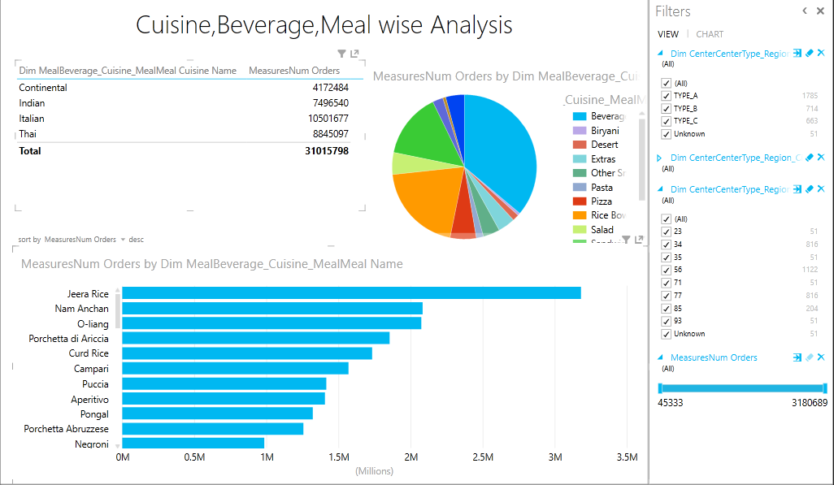

# 4.0 SSRS Reports

Accessed the SSRS web portal through the ‘Reporting Service Configuration Manager’ Web Portal URL.

Configured authorization for user.

Created a folder “SSRS_MealDemand”.

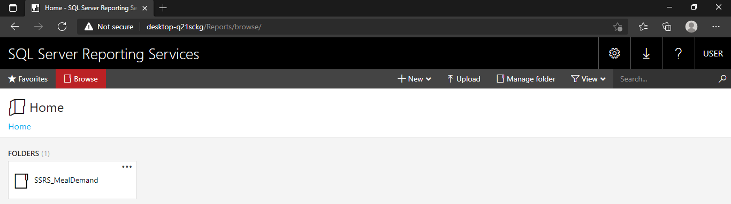

The SSRS reports were built using the ‘Report Builder’ tool.

Created a data source ‘DS_MealDemand_DW’

* Used the connection embedded only to this report
* Using SQL Server as the data base
* Connected to the ‘MealDemand_DW’ Datawarehouse which was created previously.
* Use Current windows user

Created a data set ‘DataSet1’

* Used a dataset embedded in the report
* Created a connection to the previously created data source
* Passed a query to retrieve most important data

|  |
| --- |
| Select fwd.BasePrice,fwd.CheckoutPrice,fwd.DiscountAmount,fwd.NumOrders,fwd.TotalBasePrice,fwd.TotalCheckoutPrice,  fwd.TotalDiscountPerCenterMeal, dmb.MealBeverageName,dmc.MealCuisineName,dm.MealName, dc.CenterType, dc.NumberOfEmployees,  dcc.CityCode,dr.RegionCode, dd.MonthName,dd.WeekOfMonth  from [dbo].[FactWeeklyDemand] fwd INNER JOIN [dbo].[DimMeal] dm ON fwd.[MealKey] = dm.[MealSK]  INNER JOIN [dbo].[DimMealBeverage] dmb ON dm.MealBeverageKey = dmb.MealBeverageSK INNER JOIN [dbo].[DimMealCuisine] dmc ON dm.MealCuisineKey = dmc.MealCuisineSK  INNER JOIN [dbo].[DimCenter] dc ON fwd.CenterKey = dc.CenterSK  INNER JOIN [dbo].[DimCity] dcc ON dc.CityKey = dcc.CitySK  INNER JOIN [dbo].[DimRegion] dr ON dcc.RegionKey = dr.RegionSK  INNER JOIN [dbo].[DimDate] dd ON fwd.DealDateKey = dd.DateKey |

## Report 1: Report with a matrix

Creating a report matrix

* Row groups – ‘MealCuisineName’, ‘MealBeverageName’, ‘MealName’
* Column groups – ‘NumberOfOrders’
* Values – ‘MonthName’, ‘WeekOfMonth’

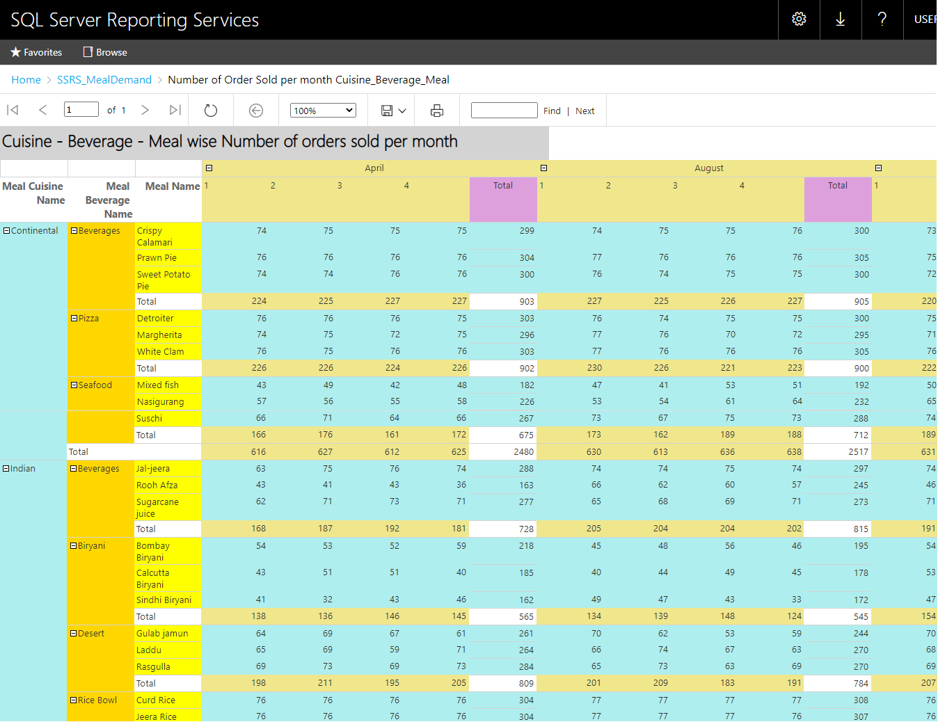

The above visualization shows the number of orders sold per month, based on the Meal Cuisine wise, Meal Beverage wise, and Meal wise in any given center.

## Report 2: Report with more than one parameter.

Creating a report matrix

* Row groups – ‘MealCuisineName’, ‘MealBeverageName’, ‘MealName’
* Column groups – ‘BasePrice’, ‘CheckoutPrice’, ‘DiscountAmount’
* Values – ‘MonthName’, ‘WeekOfMonth’

Created a new dataset ‘MealCuisine’

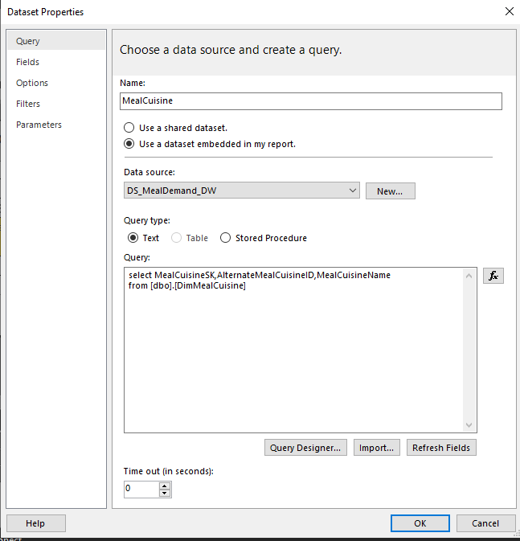

* Query passed

|  |
| --- |
| select MealCuisineSK,AlternateMealCuisineID,MealCuisineName  from [dbo].[DimMealCuisine] |

Creating multiple parameters to passed under Meal Cuisine Name.

* Creating a new parameter ‘@Meal_Cuisine’
* Allow multiple values

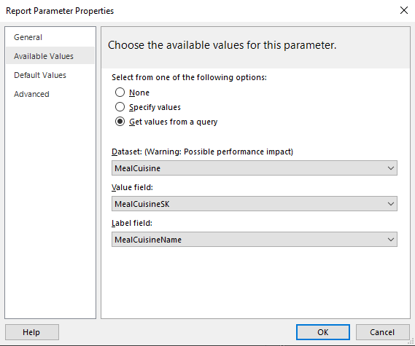

* This returns ‘MealCuisineSK’ when ‘MealCuisineName’ is passed

Created a new dataset ‘Meal’

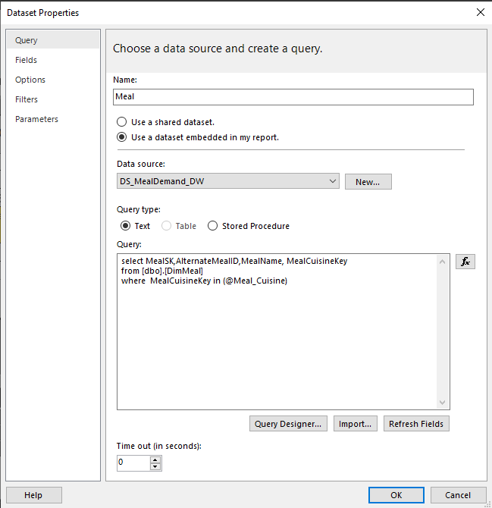

* Query passed

|  |
| --- |
| select MealSK,AlternateMealID,MealName, MealCuisineKey  from [dbo].[DimMeal]  where MealCuisineKey in (@Meal_Cuisine) |

Creating multiple parameters to passed under Meal Name.

* Creating mew parameter ‘@Meal’
* Allow multiple values

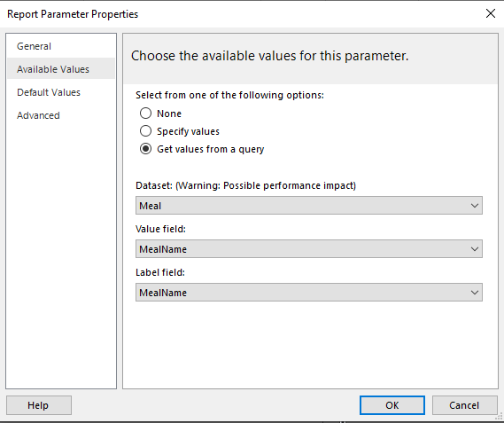

* This returns ‘MealName’ when ‘MealName’ is passed.

The DataSet1 which was created previously will be modified as below in order to retrieve the required field (Meal Name).

|  |
| --- |
| Select fwd.BasePrice,fwd.CheckoutPrice,fwd.DiscountAmount,fwd.NumOrders,fwd.TotalBasePrice,fwd.TotalCheckoutPrice,  fwd.TotalDiscountPerCenterMeal, dmb.MealBeverageName,dmc.MealCuisineName,dm.MealName, dc.CenterType, dc.NumberOfEmployees,  dcc.CityCode,dr.RegionCode, dd.MonthName,dd.WeekOfMonth  from [dbo].[FactWeeklyDemand] fwd INNER JOIN [dbo].[DimMeal] dm ON fwd.[MealKey] = dm.[MealSK]  INNER JOIN [dbo].[DimMealBeverage] dmb ON dm.MealBeverageKey = dmb.MealBeverageSK  INNER JOIN [dbo].[DimMealCuisine] dmc ON dm.MealCuisineKey = dmc.MealCuisineSK  INNER JOIN [dbo].[DimCenter] dc ON fwd.CenterKey = dc.CenterSK  INNER JOIN [dbo].[DimCity] dcc ON dc.CityKey = dcc.CitySK  INNER JOIN [dbo].[DimRegion] dr ON dcc.RegionKey = dr.RegionSK  INNER JOIN [dbo].[DimDate] dd ON fwd.DealDateKey = dd.DateKey  where dm.MealName in (@Meal) |

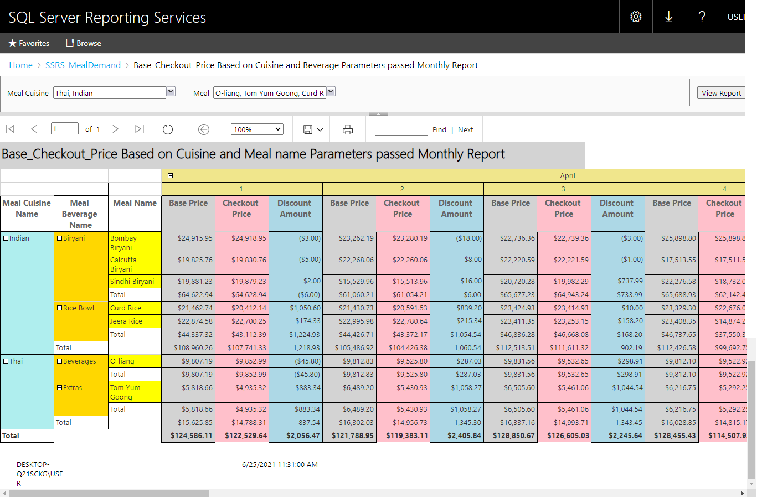

## Report 3: Create an SSRS drill-down report.

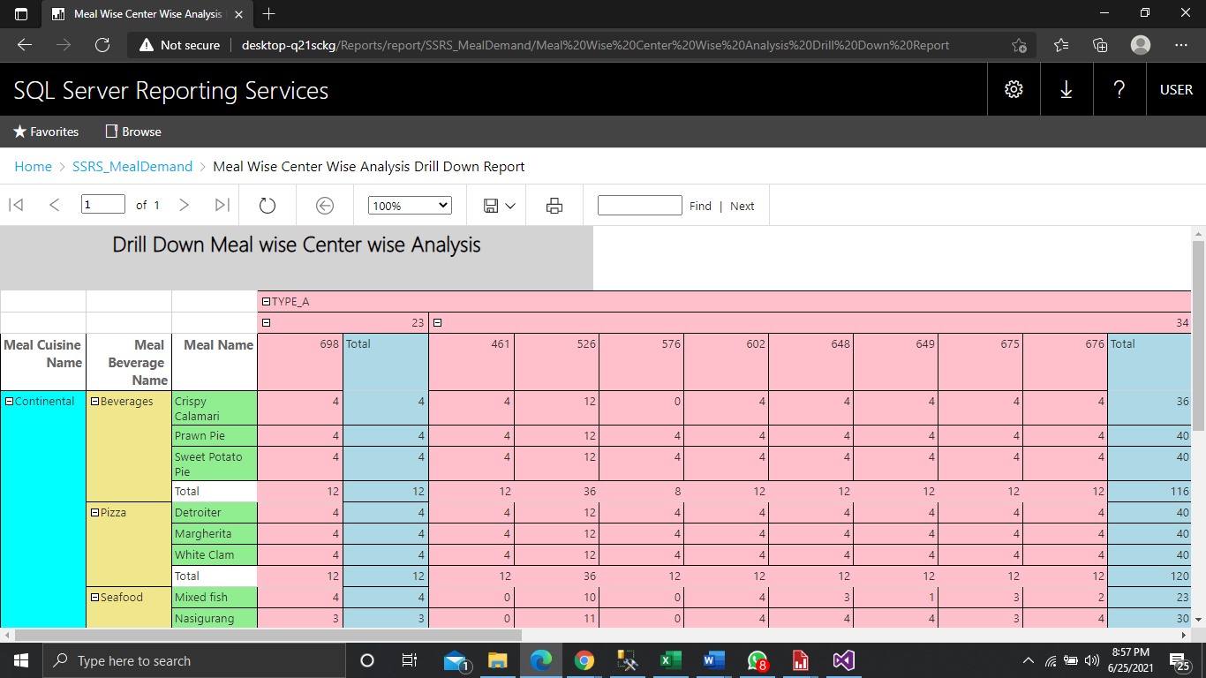

Here DimMeal and DimCenter Dimensions are mainly considered.

Drilldown can be Done Meal Cuisine wise, Meal Beverage wise and Meal wise also it can be done CenterType wise, Region wise and City wise.

## Report 4: Create an SSRS drill-through report.

First created and deployed the ‘Meal Cuisine Month wise analysis L2’

This Report shows the details of the month ‘January’ the month has been added as a filter.

By series properties 🡪 action tab we can schedule to which page the drill through report is supposed to navigate.

|  |
| --- |
| select fwd.BasePrice,fwd.CheckoutPrice,fwd.DiscountAmount,fwd.NumOrders,fwd.TotalBasePrice,fwd.TotalCheckoutPrice,  fwd.TotalDiscountPerCenterMeal, dmb.MealBeverageName,dmc.MealCuisineName,dm.MealName, dc.CenterType, dc.NumberOfEmployees,  dcc.CityCode,dr.RegionCode, dd.MonthName,dd.WeekOfMonth  from [dbo].[FactWeeklyDemand] fwd INNER JOIN [dbo].[DimMeal] dm ON fwd.[MealKey] = dm.[MealSK]  INNER JOIN [dbo].[DimMealBeverage] dmb ON dm.MealBeverageKey = dmb.MealBeverageSK  INNER JOIN [dbo].[DimMealCuisine] dmc ON dm.MealCuisineKey = dmc.MealCuisineSK  INNER JOIN [dbo].[DimCenter] dc ON fwd.CenterKey = dc.CenterSK  INNER JOIN [dbo].[DimCity] dcc ON dc.CityKey = dcc.CitySK  INNER JOIN [dbo].[DimRegion] dr ON dcc.RegionKey = dr.RegionSK  INNER JOIN [dbo].[DimDate] dd ON fwd.DealDateKey = dd.DateKey |

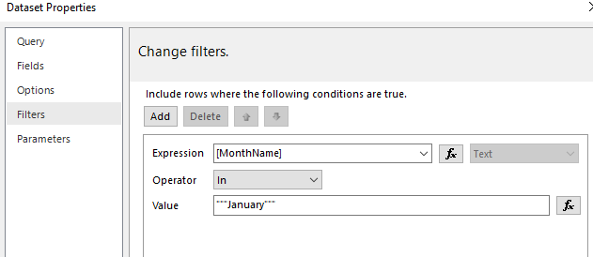

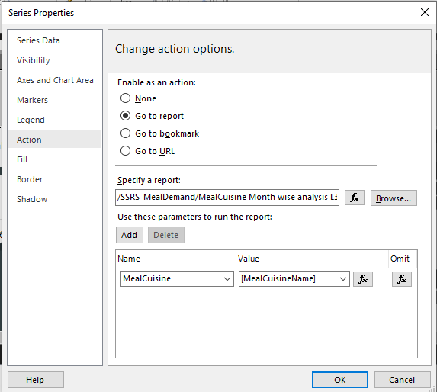

Here we are passing the meal cuisine name as the parameter so that based on the Meal Cuisine, Meal details can be analyzed on the month of January.

The meal cuisine name is passed as the parameter once the user clicks on a column of specific meal cuisine.

Created and deployed the ‘Meal Cuisine Month wise analysis L3’

Here we need a parameter Meal Cuisine in order to accept the Meal Cuisine Name passed from the previous Report.

The meal cuisine parameter is passed to the where clause in the query to retrieve details.

|  |
| --- |
| select fwd.BasePrice,fwd.CheckoutPrice,fwd.DiscountAmount,fwd.NumOrders,fwd.TotalBasePrice,fwd.TotalCheckoutPrice,  fwd.TotalDiscountPerCenterMeal, dmb.MealBeverageName,dmc.MealCuisineName,dm.MealName, dc.CenterType, dc.NumberOfEmployees,  dcc.CityCode,dr.RegionCode, dd.MonthName,dd.WeekOfMonth  from [dbo].[FactWeeklyDemand] fwd INNER JOIN [dbo].[DimMeal] dm ON fwd.[MealKey] = dm.[MealSK]  INNER JOIN [dbo].[DimMealBeverage] dmb ON dm.MealBeverageKey = dmb.MealBeverageSK  INNER JOIN [dbo].[DimMealCuisine] dmc ON dm.MealCuisineKey = dmc.MealCuisineSK  INNER JOIN [dbo].[DimCenter] dc ON fwd.CenterKey = dc.CenterSK  INNER JOIN [dbo].[DimCity] dcc ON dc.CityKey = dcc.CitySK  INNER JOIN [dbo].[DimRegion] dr ON dcc.RegionKey = dr.RegionSK  INNER JOIN [dbo].[DimDate] dd ON fwd.DealDateKey = dd.DateKey  where dmc.MealCuisineName = @MealCuisine |

Report with Meal Cuisine Analysis

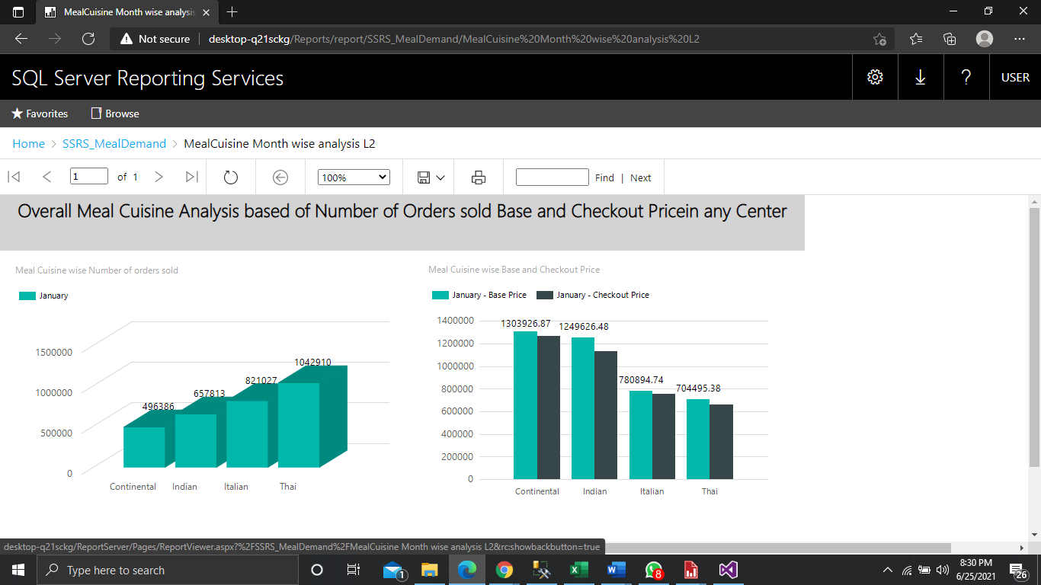

On Clicking on any Meal Cuisine, it will navigate to another page which has more details about a specific Meal in a Meal Cuisine by passing the Meal Cuisine Name as the parameter.

Report with Meal Analysis based on Meal Cuisine

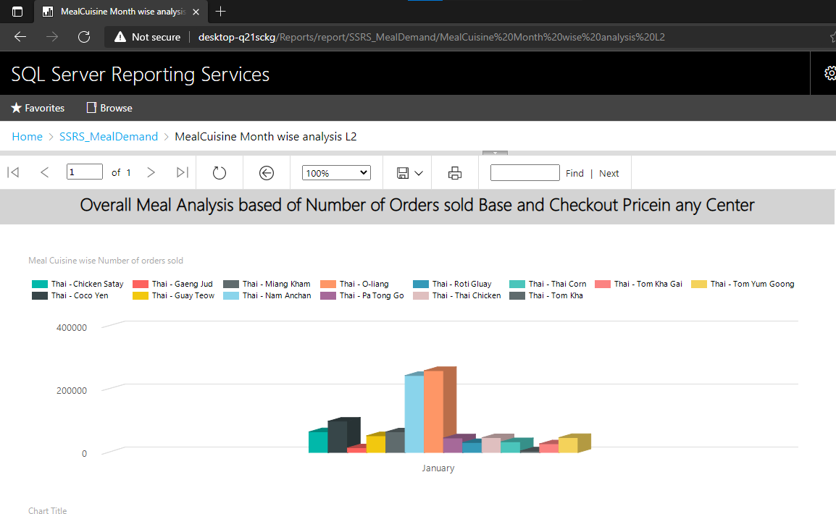

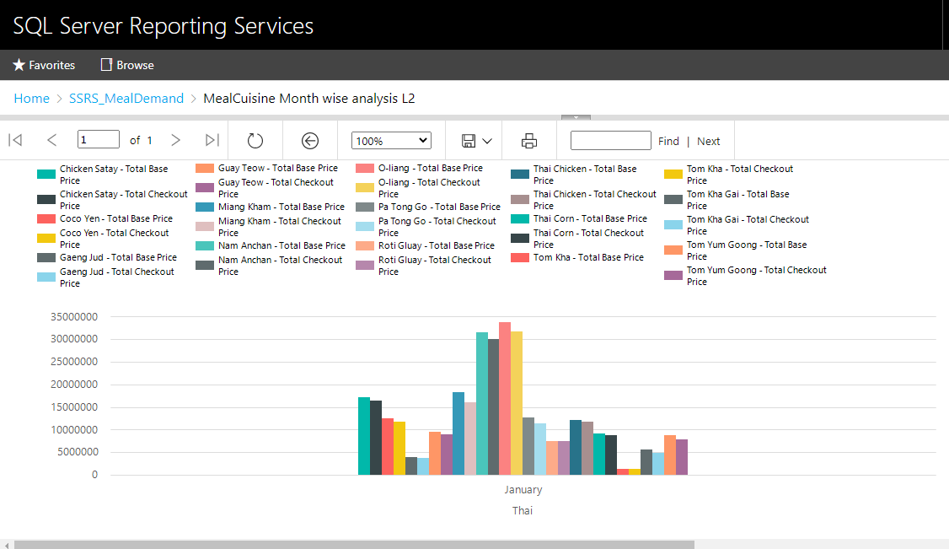

**SSRS Reports deployed in SSRS Web Portal**

